**PLAYER SPONSORSHIP 2024**

**A PLAYER SPONSORSHIP PROVIDES YOU WITH A SIGNIFICANT OPPORTUNITY TO CONTRIBUTE TO THE SUCCESS OF OUR LOCAL COMMUNITY SPORTS CLUB.**

Your sponsorship helps us put our many players on the court and field each week. It assists in meeting the costs of equipment, coaching, umpiring, insurance & medical support, to name a few.

As a player sponsor, you will receive the following:

* Membership entitlements (one for each $110 inc. GST)
* Free entry to all home & away games for GDFL and GFNL
* Thursday happy hour drinks @ West Oval (6pm to 7.30 pm)
* Siren - Siren discount drinks at all home game days
* Weekly $50 Vouched Donated by GH and The Inn when your player gets in the best each round to go in the draw to win.
* $200 End of Season Grand Prize - When your player is nominated in the best each round you will receive an entry into the end of year major prize of $2000

**Please turn over this page to complete the form.**

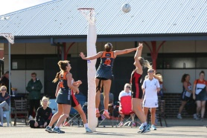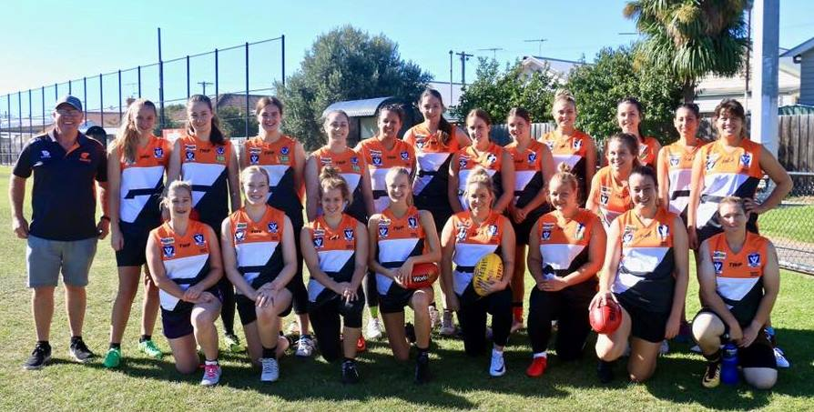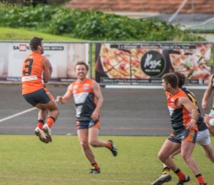

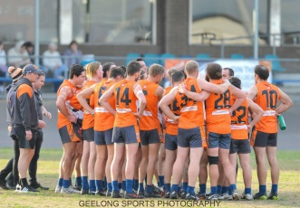

**PLAYER SPONSORSHIP FORM 2024**

**Two types of sponsorships are available. It can be completed online, scanned and emailed to** [**sponsorship@geelongwestgiants.com.au**](mailto:sponsorship@geelongwestgiants.com.au)**, post to the above address, or hand to Beth Bauer at West Oval. If sponsoring more than one player, please complete another form.**

**Player Information**

|  |  |  |  |  |  |  |  |
| --- | --- | --- | --- | --- | --- | --- | --- |
| Player Name: | | | | | **Sponsorship Options(please tick)** | **Amount (inc. GST)** |  |
| Netball A Grade / Women’s & Men’s Senior Football | $220 |  |
| Competition (please tick) | GFNL |  | GDFL |  | All Other Players (excluding Juniors) | $110 |  |

**Sponsor Information**

|  |  |
| --- | --- |
| Individual / Organisation Name: | |
| Contact Name: | |
| Address: | |
| Email: | Ph: |

**Member Information (Organisations only)**

|  |  |
| --- | --- |
| **Sponsorship Options** | Member(s) Name and email address |
| $110 All Other Players  (1 x membership) | 1. |
| $220 A Grade Netball & Women’s / Men’s Senior Football (2 x memberships) | 2. |

**Payment Options / Instructions**

|  |  |  |  |  |  |  |
| --- | --- | --- | --- | --- | --- | --- |
| Pay via the Club website at <https://www.geelongwestgiants.com.au/shop/> | |  | You can also pay with your card or cash at Beth’s Shop during opening hours. | | |  |
| Direct deposit (use “PS” and the sponsor’s name as the reference)  BSB: 633-000 Account: 159014380 | |  | Credit card – details below | | |  |
| Name on credit card | Card Number | | | Expiry date | Security code | |
|  |  | | |  |  | |

Signed (Sponsor): _____________________________________ Date:______________